**Personal Blog on IBM Cloud Static Web Apps**

**Introduction:**

To convert our personal blog design into an innovative travel blog hosted on IBM Cloud Static Web Apps,

Welcome to My Travel Blog!

Here, I'll be sharing the stories woven into the landscapes I've explored, the cultures I've encountered, and the incredible people I've met along the way.

Embarking on Adventures:

Pack your virtual bags as we traverse through enchanting cities, get lost in the beauty of nature's wonders, and immerse ourselves in the rich tapestry of diverse cultures. Each destination is not just a pin on the map but a chapter in a novel of exploration and self-discovery.

Beyond the Postcards:

This blog is more than just picturesque landscapes and iconic landmarks. It's an exploration of the authentic, the unexpected, and the extraordinary. Get ready for insights into local life, hidden gems, and the moments that transform a journey into a profound experience.

Here, some source code:

Html code:

<!DOCTYPE html>

<html lang="en">

<head>

<meta charset="UTF-8">

<meta name="viewport" content="width=device-width, initial-scale=1.0">

<title>Travel Blog</title>

<link rel="stylesheet" href="travel.css">

<link rel="preconnect" href="https://fonts.googleapis.com">

<link rel="preconnect" href="https://fonts.gstatic.com" crossorigin>

<link href="https://fonts.googleapis.com/css2?family=Poppins:ital@1&display=swap" rel="stylesheet">

</head>

<body>

<div class="header">

<nav>

<img src="travelimg/Untitled (2) (2) (1) (1).png" class="logo">

<ul class="nav-links">

<li><a href="#">Popular Places</a></li>

<li><a href="#">Travel Outside</a></li>

<li><a href="#">Online Packages</a></li>

</ul>

<a href="#" class="register-btn" >Register Now</a>

</nav>

<div class="container">

<h1>Find Your Next Stay</h1>

<div class="search-bar">

<form>

<div class="Location-input">

<label>Location</label>

<input type="text" placeholder="Where are you going?">

</div>

<div>

<label>Check in</label>

<input type="text" placeholder="Add Date">

</div>

<div>

<label>Check out</label>

<input type="text" placeholder="Add Date">

</div>

<div>

<label>Guest</label>

<input type="text" placeholder="Add Guest">

</div>

<button type="submit"><img src="travelimg/search.png"></button>

</form>

</div>

</div>

</div>

<div class="container">

<h2>Exclusives</h2>

</div>

</body>

</html>

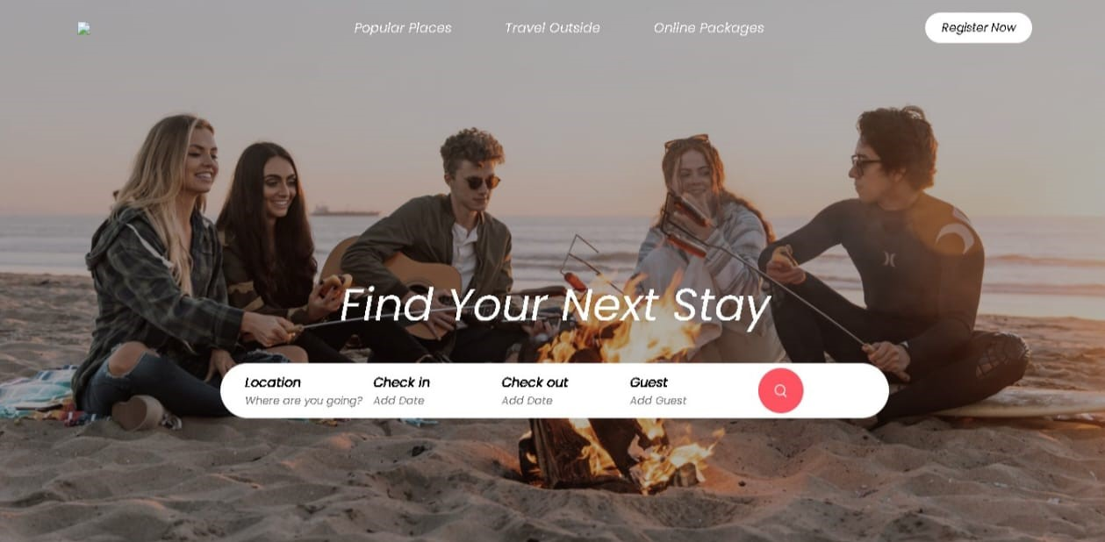

Css code:

[7:36 pm, 30/10/2023] Dhatchu: *

{

margin: 0;

padding: 0;

box-sizing:border-box;

font-family: 'Poppins', sans-serif;

}

.header{

min-height: 100vh;

width: 100%;

background-image: linear-gradient(rgba(0,0,0,0.3),rgba(0,0,0,0.3)),url(travelimg/banner.png);

background-size: cover;

background-position: center;

}

nav{

display: flex;

align-items: center;

justify-content: space-between;

padding: 20px 7%;

}

.logo{

width: 140px;

cursor: pointer;

}

.nav-links li{

list-style: none;

display: inline-block;

margin: 10px 30px;

}

.nav-links li a{

text-decoration: none;

color: #fff;

}

.register-btn{

background: white;

color:#000;

padding: 8px 20px;

border-radius: 20px;

text-decoration: none;

font-size: 14px;

}

.container{

padding: 0 7%;

}

.header h1{

font-size: 4vw;

font-weight: 500;

color: #fff;

text-align: center;

padding-top: 22%;

}

.search-bar{

background: #fff;

width: 70%;

margin: 30px auto;

padding: 6px 10px 6px 30px;

border-radius: 50px;

}

.search-bar form{

display: flex;

align-items: center;

flex-wrap: wrap;

}

.search-bar form input{

display: block;

border: 0;

outline: none;

background: transparent;

}

.search-bar form button{

background: #ff5361;

width: 55px;

height: 55px;

border-radius: 50%;

border: 0;

outline: none;

cursor: pointer;

}

.search-bar form button img{

width: 15px;

margin-top: 7px;

}

.location-input{

flex: 1;

}

.search-bar form label{

font-weight: 600;

}

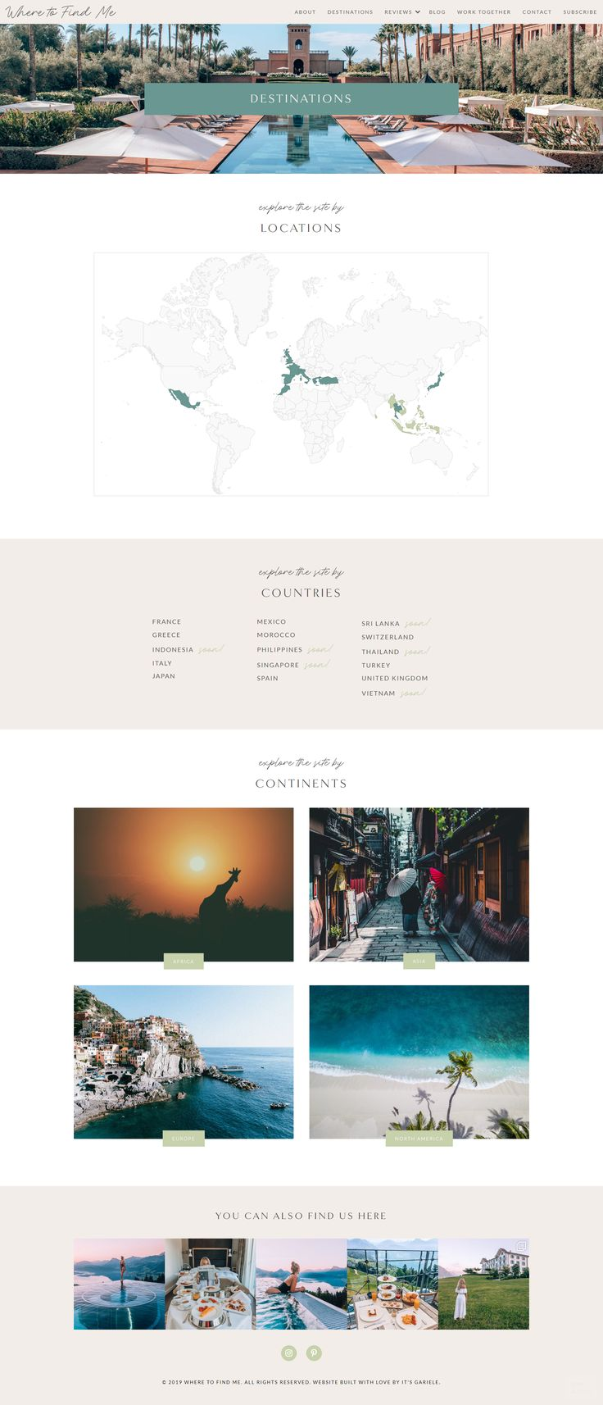

**Conclusion:**

By implementing these strategies, you can transform your blog into an innovative travel platform that inspires and informs fellow travelerwhile leveraging the capabilities of IBM Cloud Static Web Apps for hosting and reliability.